

**A**

**Synopis Report**

**on**

**AFFLX**

**Bachelor of Computer Application**

**(B.C.A)**

**3ththth Year(6th Sem.)**

**Academic year**

**(2018-2021)**

**Submitted to: Submitted by:**

**Prof. Anuj Sharma Mr. Samir Chouhan**

**Prof. Priyanka Sharma**

**PROJECT SYNOPSIS**

**Title: **

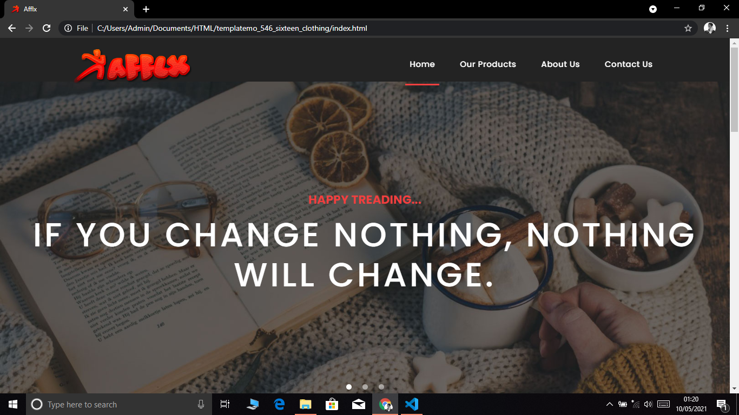

**Introduction:**

Our product is going to be a free online classified service using which people can buy and sale a lot of things in a smooth manner. It should be made available as a website and there should be dedicated mobile apps too.  
A lot can be done using this versatile classified service like:

* Put up ads for selling your belongings like gadgets, apparel, property, cars and bikes, and even pets.
* As a buyer, you can look for stuff within the price range or available in your preferred occasions.
* As a seller, put in the details of the stuff you want to sell in your ads. As a buyer, you can look for stuff within the price range or available in your preferred locations. Add images of the stuff you want to sell through the app.
* You can choose to be contacted by others by email, phone number and both

**Objective:**

The main objective of **Afflx** is that customer’s can trade with each other, typically in an online environment. Customer’s satisfaction is our primary goal. We provide best online environment to purchase and sale any product customer want to sale or buy.

**Problem Definition:**

Purchase and sale of good via business outlet with one or few physical locations. Customers reach is limited. Availability limited time. It can only be operated from store and has limited marketing possibilities. Business expansion only in local area. Refund and retain rate are low. Cannot sale in multiple store and it take more time and effort to scale a business. It take limited visibility audience and takes time to build as brand. And broker between to person , who charge some amount to his client after deal done.

**Problem Solution:**

Purchase and sale of good via a digital platform such as an online website. It has global reach and cost of update is less. Its online platform to trade that’s have a biggest advantage of 24x7 availability, traders can access platform any time anywhere in the world. A broad range of promotion and marketing feature available .Business expansion is in the world and have high refund/return rate and have less operation cost. Less time and efforts require scaling business and high dependence on a platform.

**Tools and technology:**

To create **Afflx** we use following tools and technology:

* **For Front End**
* **HTML**
* **CSS**
* **JAVASCRIPT**
* **Software Application**
* **NetBeans**
* **Mysql**
* **Operating System**
* **Windows 10**

**List and Feature:**

* **Log in options multiple:** You can log into to the app either for selling or buying anything using 4 options. You can use Google or Facebook id. You may also use a phone number or email id for logging in.
* **Profile customization:** Once you are logged in and registered with the app, profile customization can be done. You can choose a phone number to be displayed in the ads. You may also add a profile picture.
* **Notifications:** You may choose to be notified on promotional offers and activity-based recommendations.
* **Real estate:** Apart from used stuff, you can use the marketplace app to look for real estate deals. You may search for rented properties using its service. Using filters the type of property

**Conclusion:**

At the last we conclude that this project is about Customer’s satisfaction. And people can easily buy and sale there product in a smooth manner. It is easy to access.

**[That’s all about Afflx]**